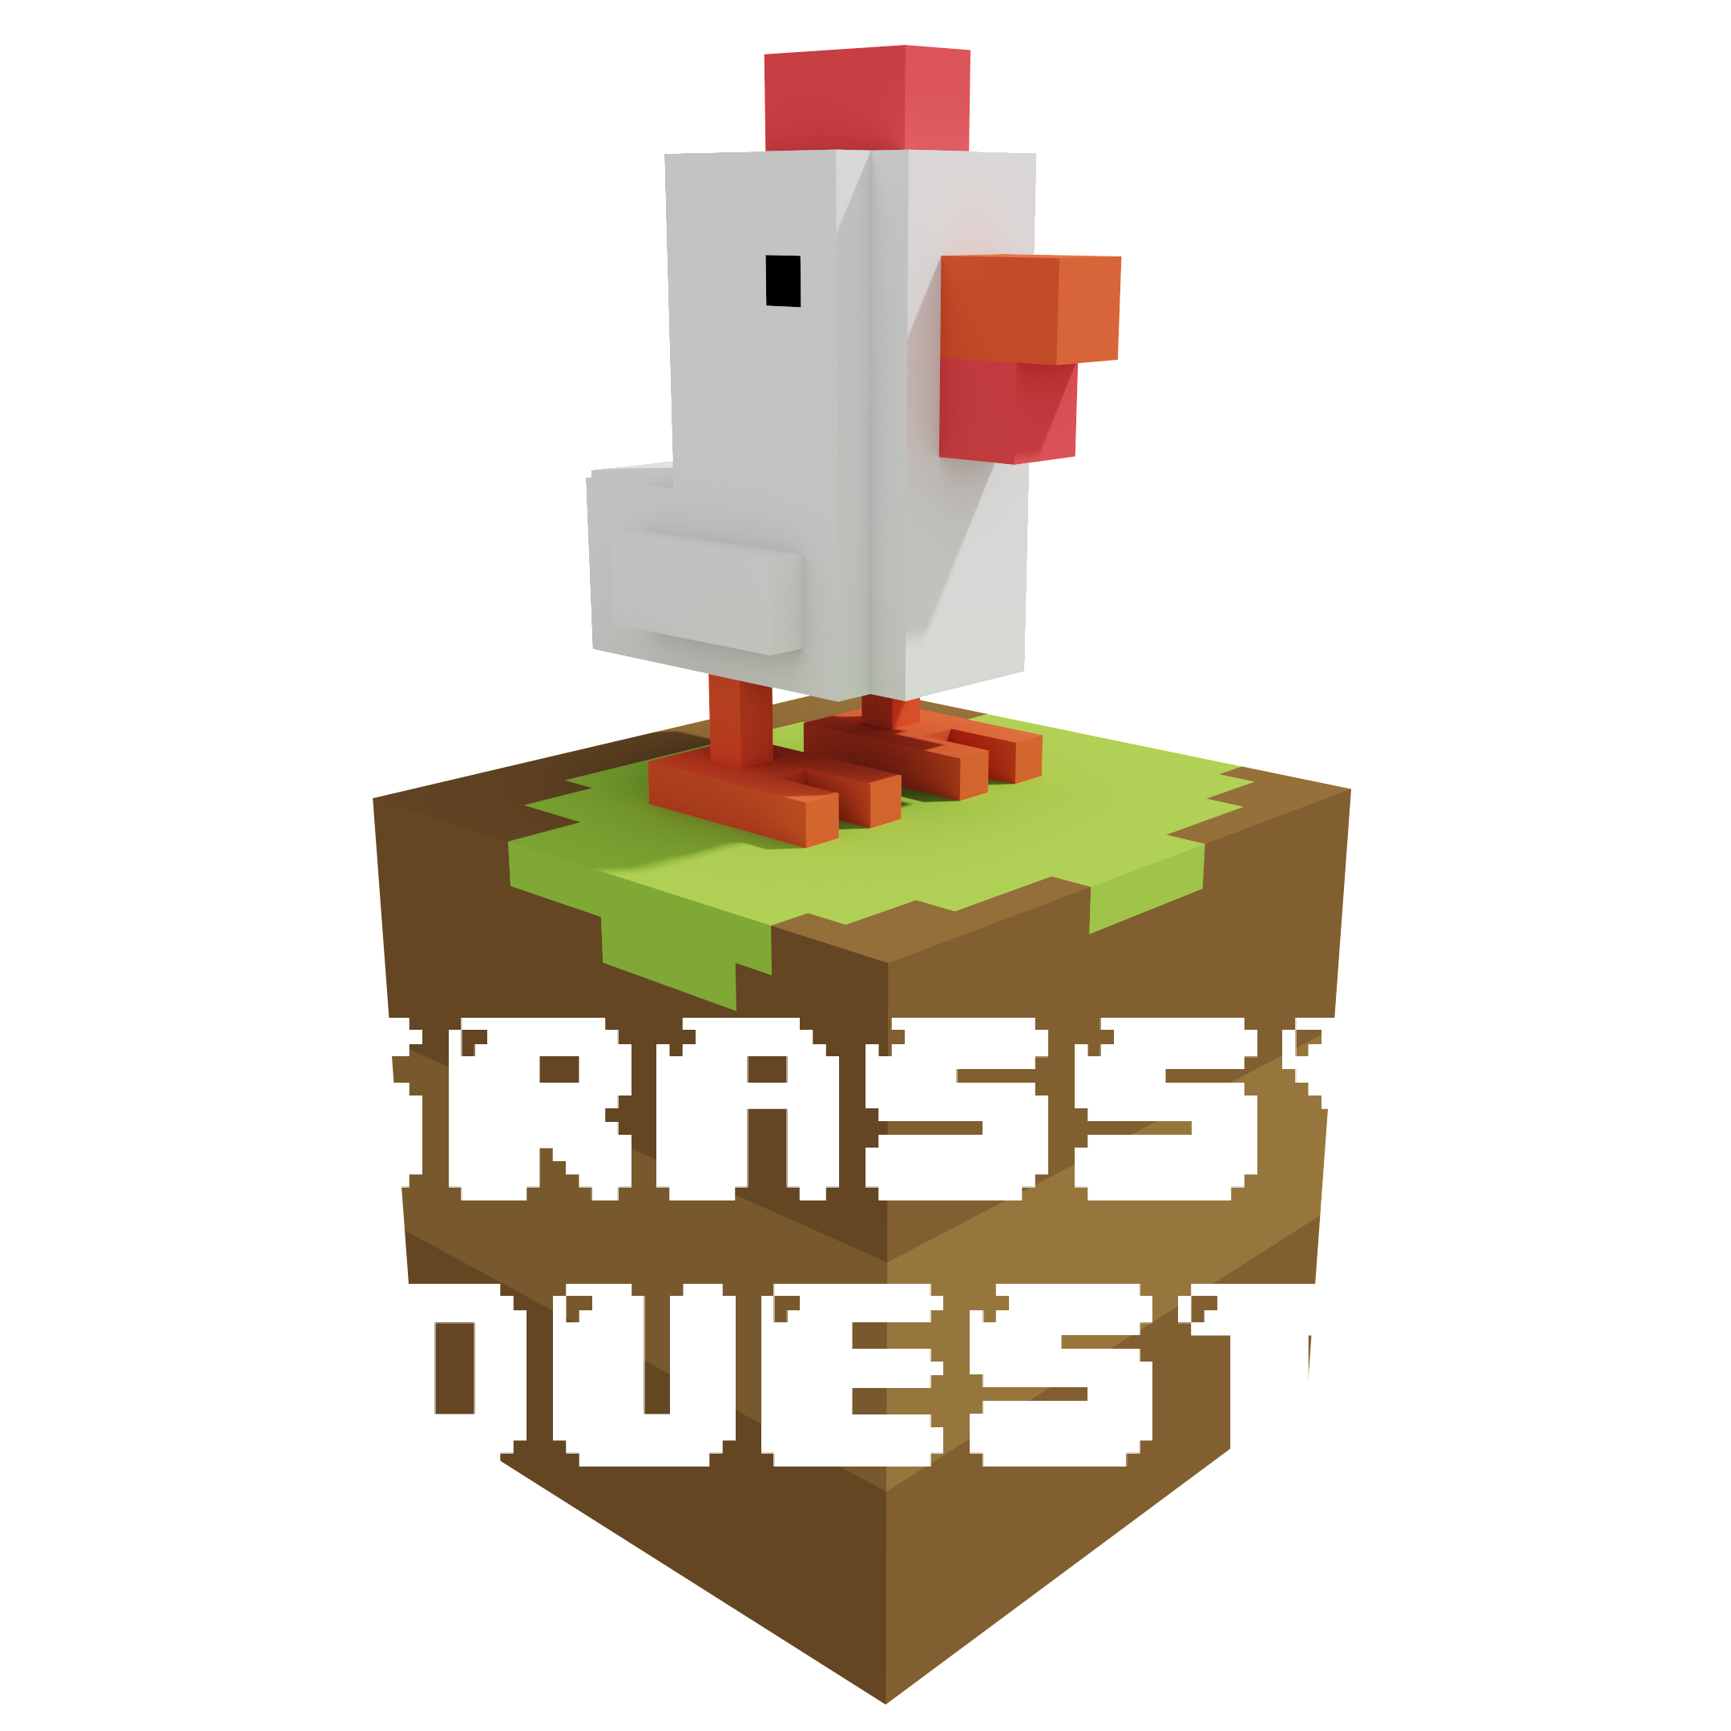

**GAME DESIGN DOCUMENT**

LAST UPDATED:

30/04/24

PREPARED BU:

SNAGBOX GAMES

**TABLE OF CONTENTS**

Short description 3

Gameplay 3

Overview of Gameplay 3

Description 3

Characters 3

Control 4

Level Design 5

Losing 6

Art Style 7

Demographics 7

Platforms 7

Localization 7

# Short description

GRASSY QUEST is an exciting puzzle game where you control characters to paint over the grass and collect food! Use your logical skills to find the best path and complete the levels while avoiding obstacles and traps. Pave the way to success with your feathered friends!

# Gameplay

## Overview of Gameplay

The gameplay in Grassy Quest is reminiscent of the classic Sokoban game. The player can move through the level by repainting the grass in bright colors with their characters and collecting available food on their way.

## Description

GRASSY QUEST is an exciting puzzle game that invites you on an exciting adventure with characters who can paint over the grass and collect food. In this game, you will use your logical abilities and strategic mindset to overcome various obstacles and complete the levels.

During the game you will have to solve a variety of puzzles and logical tasks. You will have to make your way through the maze of grass, avoiding obstacles, traps and other dangers on your way. Each level will offer you new challenges and opportunities to express your creativity and strategic thinking.

GRASSY QUEST offers you an exciting game environment full of bright colors, funny characters and exciting adventures. Dozens of levels are waiting for you, each of which will offer you new opportunities for development and variety in the gameplay.

Join this unique adventure and pave your way to success with your feathered friends in the "GRASSY QUEST"!

## Characters

In "Grassy Quest" there are a variety of characters represented by different species. You can also buy various skins in the game.

## Control

The game has simple character control, which allows you to focus on making decisions rather than managing your character.

## Level Design

The level is a set of cubes through which you need to move. There will be 96 levels in total, divided into 4 difficulty groups.

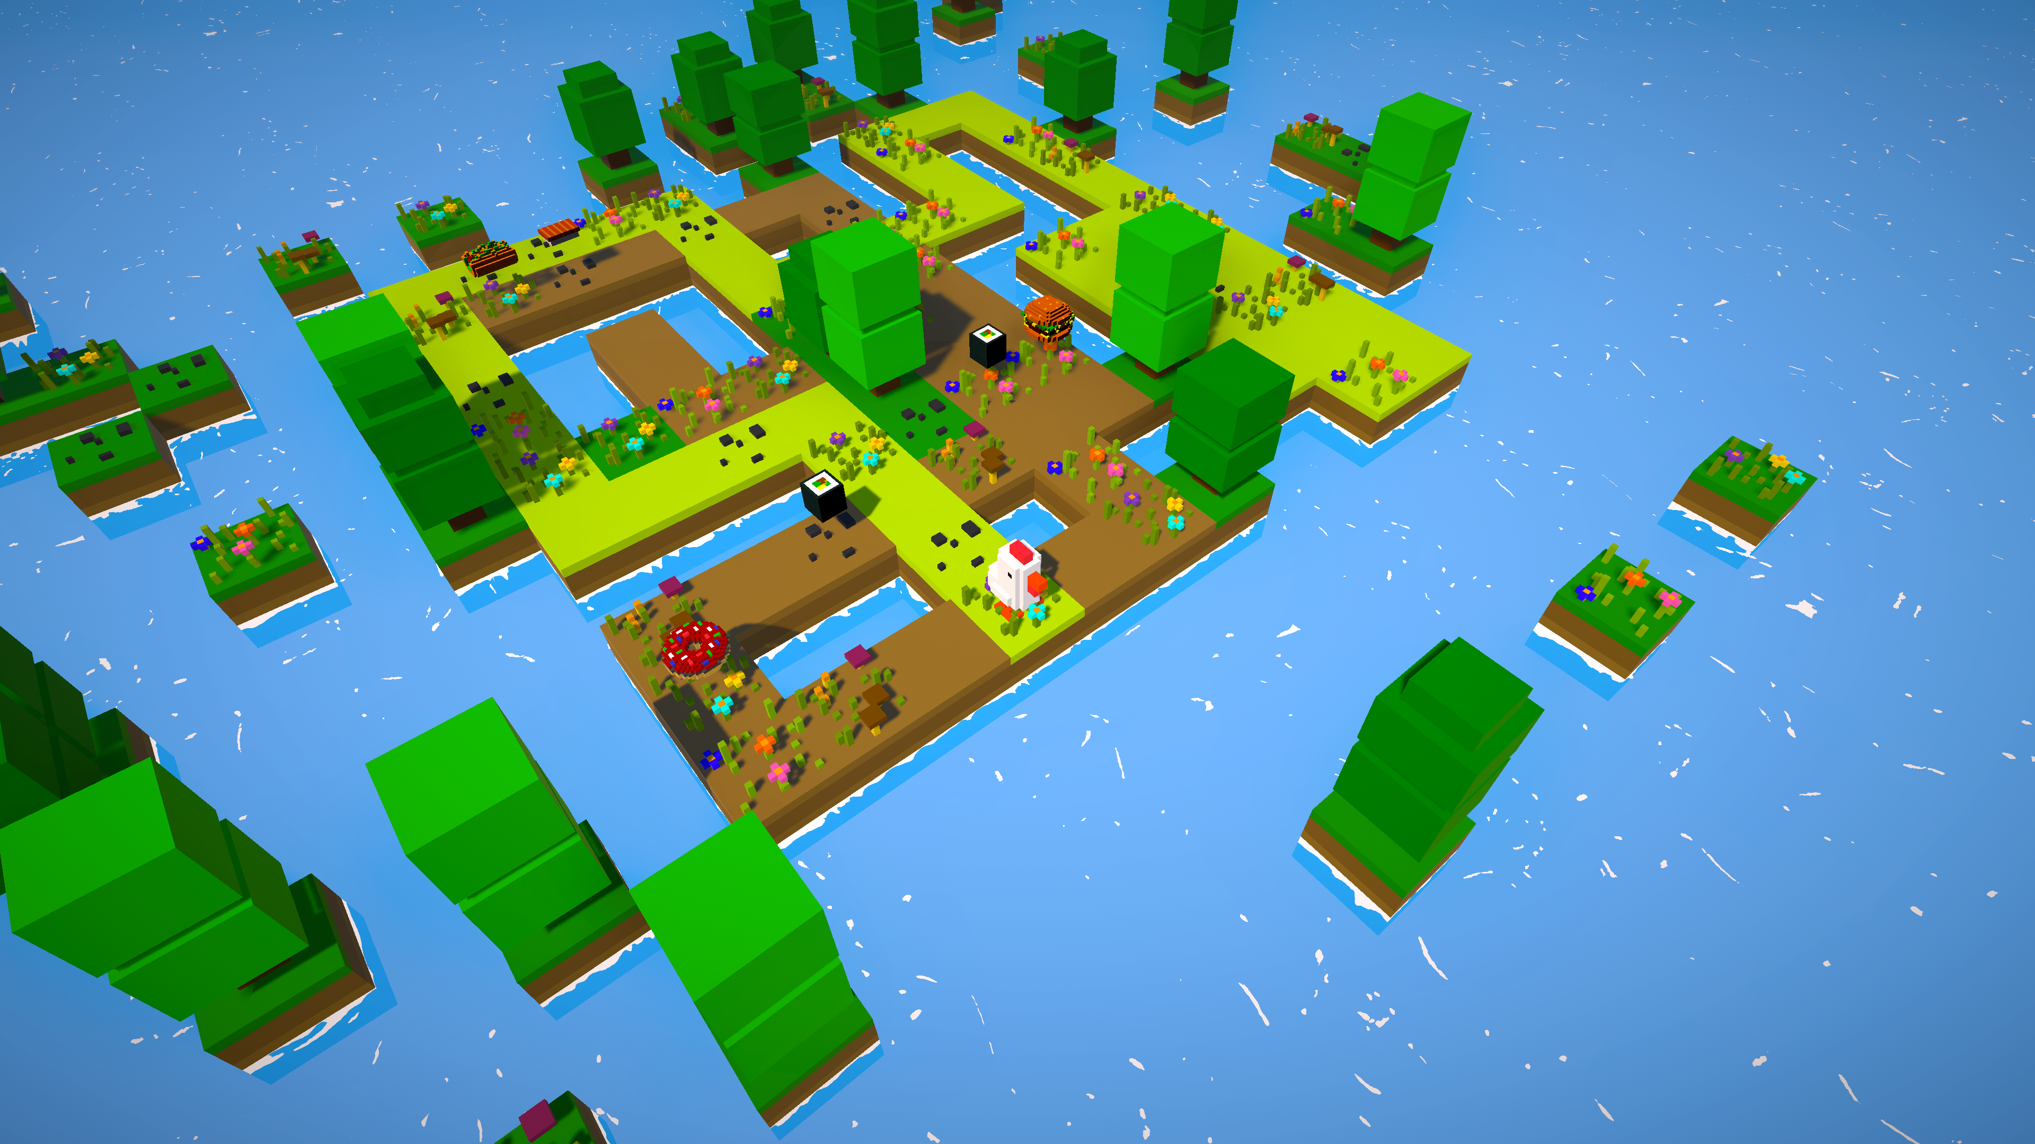

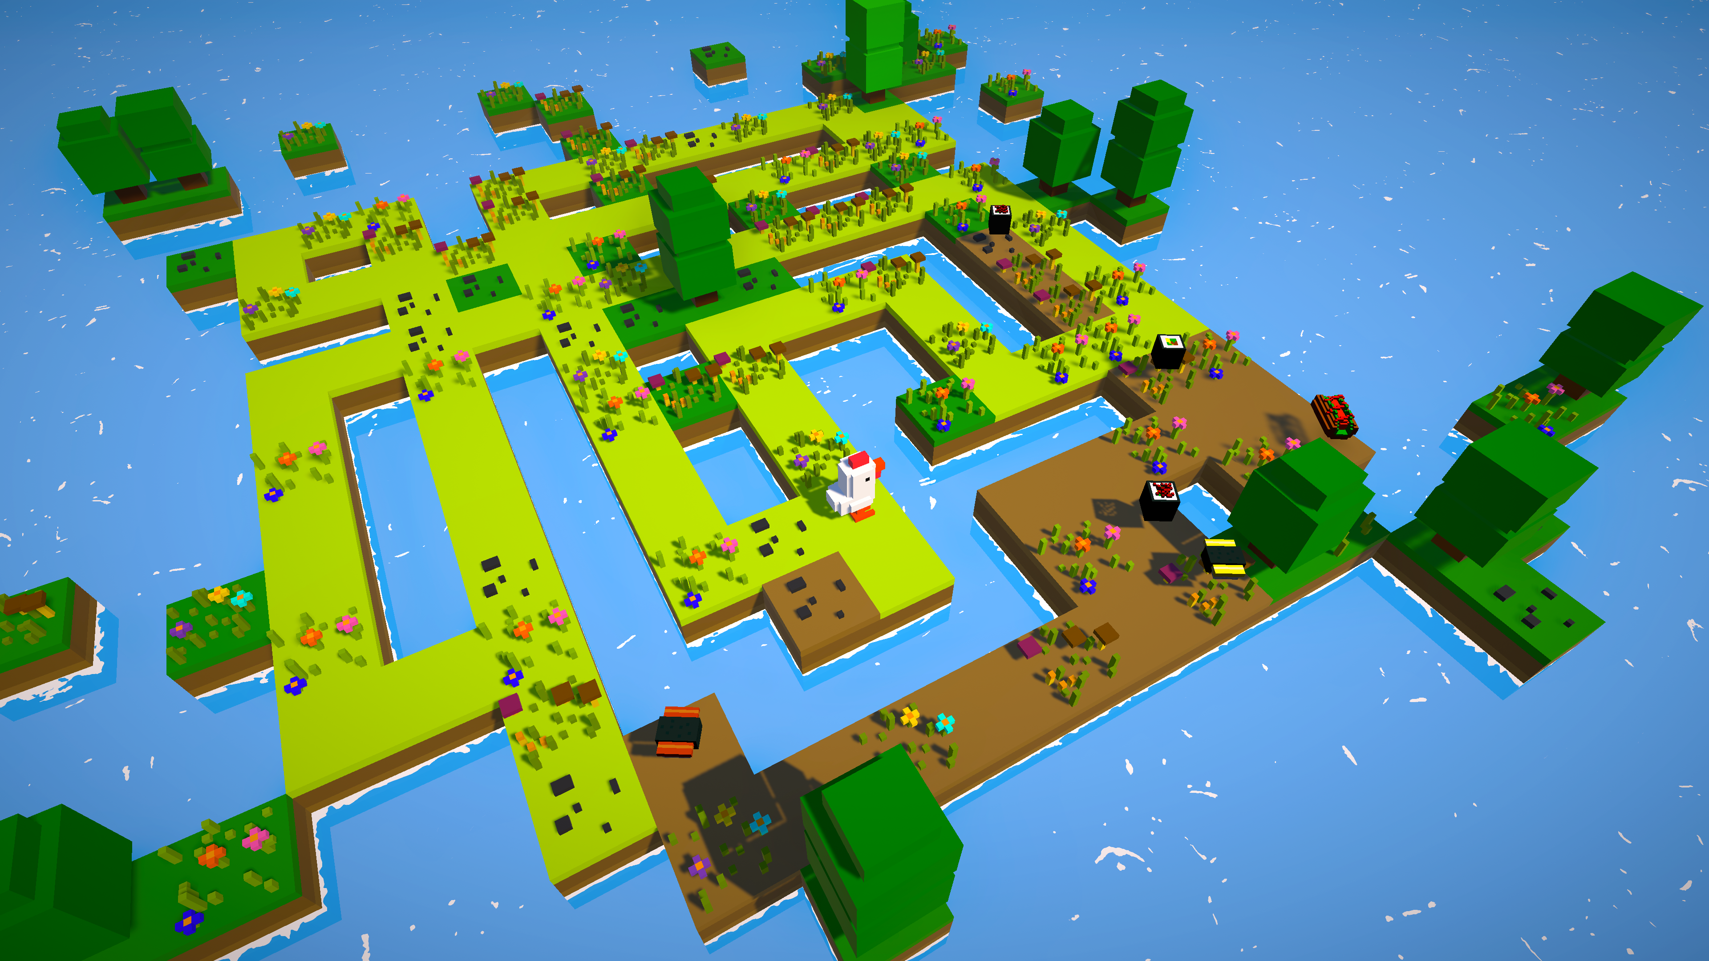

# Losing

The player has only one chance to complete each level. If the player falls into a trap, he will have to start all over again.

# Art Style

The game was made in a minimalist voxel style with the unique palette. We tried to use soft solid colors, so as not to burden a gamer.

# Demographics

The game intended for the audience of 6+.

# Platforms

Originally release of the game is planned for PlayStation platform. We also consider the release for Xbox, PC and Nintendo.

# Localization

At this stage, Russian, English, French, Japanese, German, Spanish, Portuguese and Chinese localization have been added.